1. Setup grails in eclipse
2. Make sure JDK is your default java version
3. Import Grails project  
   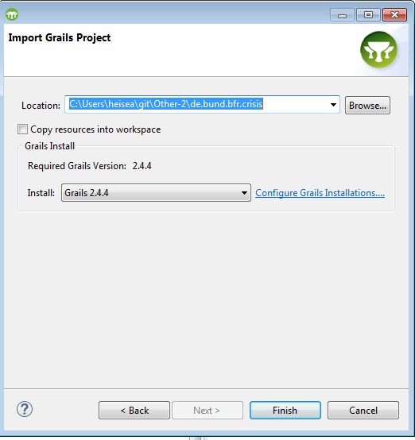
4. Eclipse automatically refreshes Grails dependencies
5. Optionally:   
   *grails add-proxy bfr --host=webproxy.bfr.bund.de --port=3128  
   grails set-proxy bfr*
6. Add gwt sources to build path (possibly add src/groovy to build path as well)  
   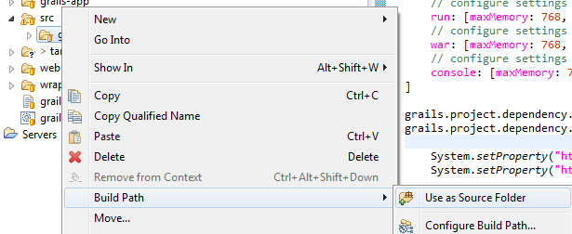  
   At this point, no build error should remain
7. If error still there: Eclipse Restart -> errors are gone (maybe a project clean would have been sufficient…)!
8. Create GWT module (needs to be repeated when deploying app)  
   *grails compile-gwt-modules –draftCompile TracingApp <module_names>*

*[de.bund.bfr.crisis/src/gwt/de/bund/bfr/crisis/TracingApp.gwt.xml]*  
Module names can be empty and the script will automatically find them in src/gwt

*Sufficient is: compile-gwt-modules*

1. Run GWT code server  
   *grails run-gwt-codeserver*Enables on-the-fly compilation
2. Run grails server  
   *grails run-app*  
   It’s normal that certain error messages occur during development.
3. For Javascript debugging install GWT and SDBG plugins (<http://sdbg.github.io/>)   
   Launch chrome instance with SDBG plugin as shown in the video ^
4. If errors still remain, try:   
   grails clean  
   and remove: .link_to_grails_plugins, .settings, target, target-eclipse, web-app/gwt